Programming Projects for Chap. 6:

Project 1: The Sleeping Teaching Assistant

Room: 1 desk with a chair and computer

Hallway: 3 chairs

POSIX threads, mutex locks, and semaphores

使用semaphore安排等待學生的順序，並分別建立助教及學生相對應的thread，隨機給予學生詢問的時間，結果如下:

截圖畫面:

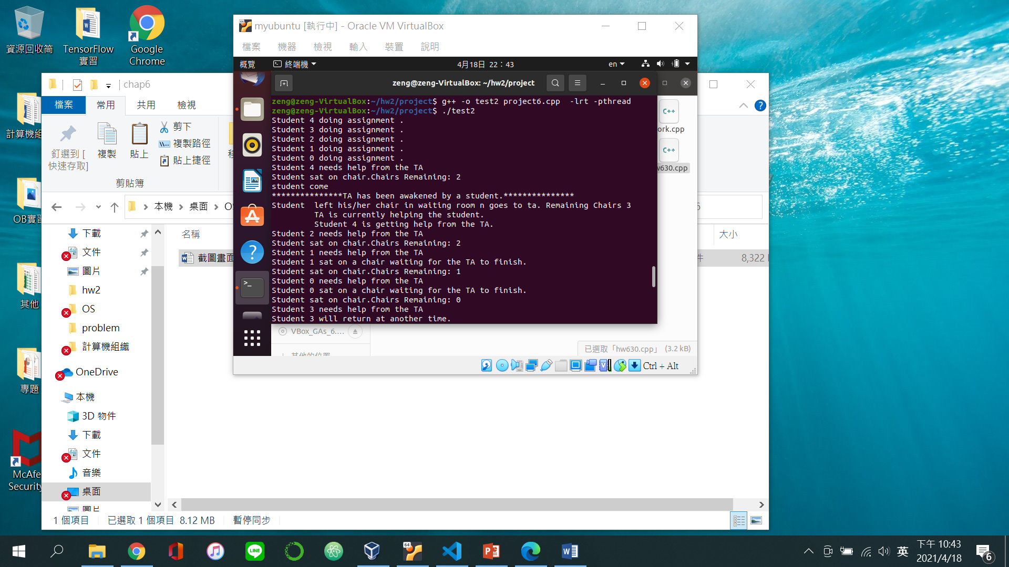

4.19\*: Write a multithreaded program that outputs prime numbers. The user will run the program and will enter a number on the command line. The program will then create a separate thread that outputs all the prime numbers less than or equal to the number entered by the user.

使用thread產生一個獨立的thread算出小於等於使用者輸入的數字的質數。

截圖畫面:

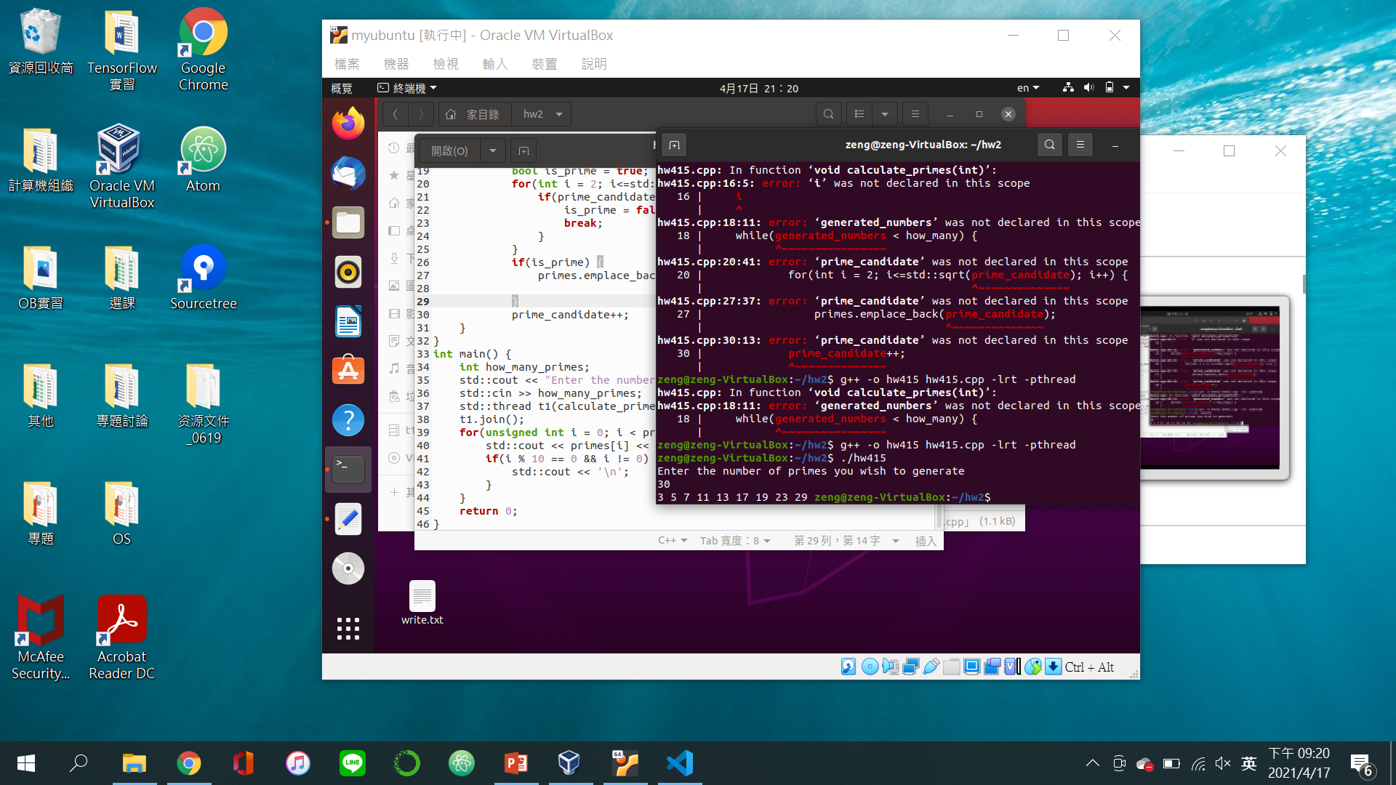

6.30\*: Programming Exercise 3.13 required you to design a PID manager that allocated a unique process identifier to each process. Exercise 4.15 required you to modify you solution to Exercise 3.13 by writing a program that created a number of threads that requested and released process identifiers.

Now modify your solution to Exercise 4.15 by ensuring that the data structure used to represent the availability of process identifiers is safe from race conditions. Use mutex locks in Pthreads, Windows threads, or Java threads.

原有的程式架構下加入mutex lock，讓每個pthread不會同個時間進行程序。

截圖畫面:

